## **Day 4 A assignment 1**

## **Scrum vs. Kanban: Key Differences**

Here's a point-by-point comparison of Scrum and Kanban, along with additional details to help you choose the right approach for your project:

**Structure**

* **Scrum:**
  + **Highly structured:** Defines specific roles (Product Owner prioritizes features, Scrum Master facilitates the process, Developers complete the work), ceremonies (regular meetings for planning, reviewing, and adapting), and artifacts (product backlog, sprint backlog, and the completed increment of work).
  + **Fixed-length sprints:** Work is planned and completed in short, time-boxed iterations (typically 2-4 weeks). This promotes focus and a sense of accomplishment.
  + 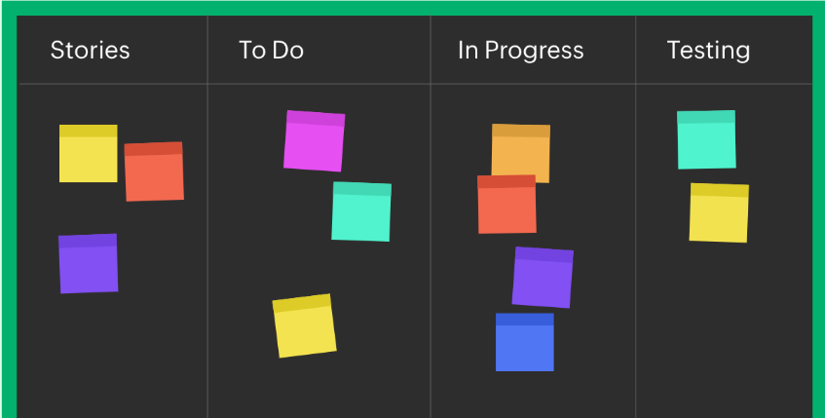
* **Kanban:**
  + **Lighter structure:** Focuses on visualizing workflow and continuous work flow.
  + **Kanban Board:** Central tool for visualizing tasks. These tasks move through different stages representing the workflow (e.g., To Do, In Progress, Done).
  + **Flexible workflow:** Work progresses through stages as capacity allows, adapting to changing priorities.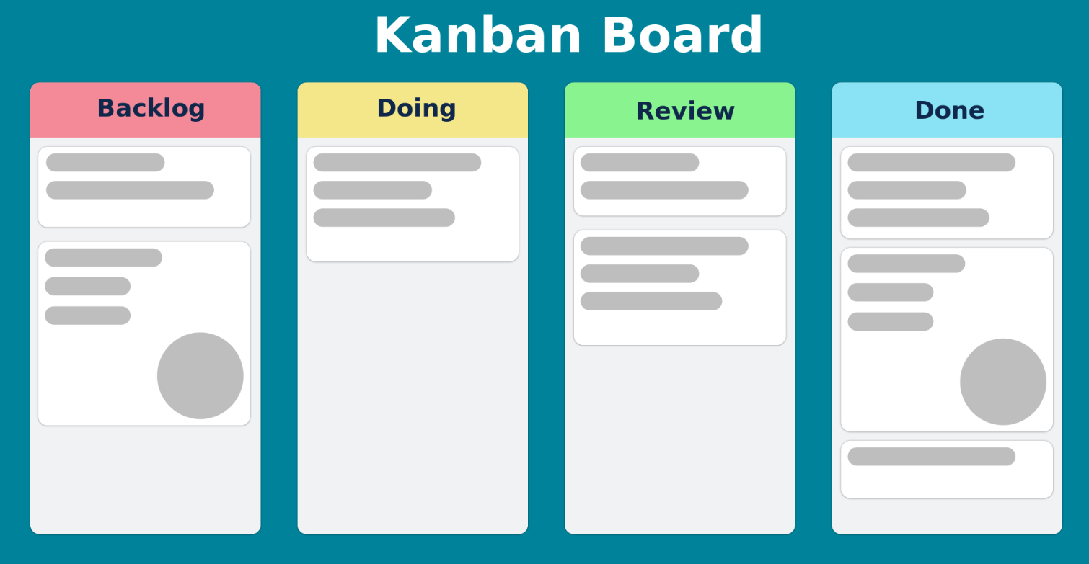

**Focus**

* **Scrum:**
  + **Deliverables:** Emphasis on delivering a potentially shippable product increment at the end of each sprint.
  + **Planning & Adapting:** Scrum promotes planning within the sprint cycle, with opportunities to inspect progress and adapt the plan during daily meetings and reviews.
* **Kanban:**
  + **Workflow Optimization:** Focuses on optimizing the flow of work, ensuring smooth progress and avoiding bottlenecks.
  + **Continuous Improvement:** Kanban emphasizes ongoing improvement by identifying and eliminating inefficiencies in the workflow.

**Suitability**

* **Scrum:**
  + **Clear Goals:** Well-suited for projects with clear goals that can be broken down into smaller user stories or features.
  + **Evolving Requirements:** Good for complex projects where requirements may evolve but there's a defined end goal. The sprint cycle allows for adaptation within a clear vision.
* **Kanban:**
  + **Ongoing Work:** Works well for projects with ongoing or unpredictable work, where requirements change frequently.
  + **Maintenance & Support:** Effective for managing maintenance and support tasks where new issues constantly arise and need to be addressed.

**Choosing the Right Method**

* **Scrum:** Choose Scrum if your project has a clear vision, requires focused delivery in phases, and benefits from regular inspection and adaptation cycles.
* **Kanban:** Choose Kanban if your project has ongoing or unpredictable work, requires continuous flow and flexibility, and prioritizes continuous improvement of the workflow.